###### **SMART AND ENERGY EFFICIENT ROOM AUTOMATED SYSTEM**

###### A comprehensive project report has been submitted in fulfillment of the year long project for requirements for the degree of

## Bachelor of Technology

###### Under the supervision of

#### Dr. Pushpa Raikwal

##### Professor

#### Department of Electronics and Communication Engineering

#### 

Indian Institute of Information Technology, Design and Manufacturing, Jabalpur

52GG+G48, PDPM IIITDM Jabalpur Campus, Khamaria, Jabalpur, Madhya Pradesh 482005

### May,2023

## CERTIFICATE



This is to certify that the project titled **SMART AND ENERGY EFFICIENT** **HOME AUTOMATED SYSTEM** carried out by

|  |  |
| --- | --- |
| Name | Roll No. |
| **RAHUL KUMAR** | **20BEC081** |
| **SUDHANSHU NARAYAN** | **20BEC108** |
| **PRASHANT KUMAR SINGH** | **20BEC074** |
| **RACHIT GARG** | **20BEC080** |
| **SIDDHANT RAI** | **20BEC103** |
| **SAURABH JHA** | **20BME054** |
| **SAI PRIYANKA** | **20BEC097** |

for the Fabrication Project for B.Tech degree from **Indian Institute of Information Technology, Design and Manufacturing, Jabalpur** is absolutely based on our own genuine work under the supervision of Dr. Pushpa Raikwal. The contents of this report, in full or in parts, have not been submitted to any other Institute or University.

|  |  |
| --- | --- |
|  | .........................................................  **Dr. Pushpa Raikwal**  Professor , Dept. of ECE  Indian Institute of Information Technology, Design and Manufacturing ,Jabalpur |

# DECLARATION



##### We Do hereby declare that this submission is our own work conformed to the norms and guidelines given in the Ethical Code of Conduct of the Institute and that, to the best of our knowledge and belief, it contains no material previously written by another neither person nor material (data, theoretical analysis, figures, and text) which has been accepted for the award of any other degree or diploma of the university or other institute of higher learning, except where due acknowledgement has been made in the text.

# ACKNOWLEDGEMENT

We would like to express our gratitude and appreciation to all those who gave us the   responsibility to complete this report.

First and foremost, we would like to express our gratitude to **Dr. Pushpa Raikwal** for giving us this opportunity and being a constant source of motivation.

We would also like to acknowledge with much appreciation the crucial role of Dr. Vijay Kumar Gupta - their active help in issuing components for the project that removed hurdles of lack of components for some time.







**Signature of Candidates**

ABSTRACT

The main objective of this project is to develop a home automation system using an NodeMCU being remotely controlled by application on any Android OS smart phone and voice commands. As technology is advancing so houses are also getting smarter. Modern houses are gradually shifting from conventional switches to centralized control system. Presently, conventional wall switches located in different parts of the house makes it difficult for the user to go near them to operate. Even more it becomes more difficult for the elderly or physically handicapped people to do so. Remote controlled home automation system provides a most modern solution with smart phones. GUI application on the cell phone sends ON/OFF commands to the receiver where loads are connected. By touching the specified location on the GUI, the loads can be turned ON/OFF remotely through this technology.

CONTENTS

CERTIFICATE… 1

DECLARATION 2

ACKNOWLEDGEMENT 3

ABSTRACT 5

CONTENTS… 6

INTRODUCTION 8

COMPONENTS REQUIRED… 9

DESCRIPTION 10

LITERATURE 14

CAMERA MODULE AND OPEN CV 17

VOICE CONTROL FUNCTIONS 20

NODE MCU WORKING 21

RELAY 22

HOME AUTOMATION WEBSITE 23

HOME AUTOMATION APP………………………………………………………………….25

CONCLUSION ………………………………………………………………………………….26

REFRENCES……………………………………………………………………………………..26

INTRODUCTION

Nowadays, we have remote controls for our television sets and other electronic systems, which have made our lives real easy. Have you ever wondered about home automation which would give the facility of controlling tube lights, fans and other electrical appliances at home using a remote control? Off-course, Yes! But, are the available options cost-effective? If the answer is No, we have found a solution to it. We have come up with a new system of machine learning based home automation using Bluetooth. This system is super-cost effective and can give the user, the ability to control any electronic device without even spending for a remote control. This project helps the user to control all the electronic devices using his/her smartphone. Time is a very valuable thing. Everybody wants to save time as much as they can. New technologies are being introduced to save our time. To save people’s time we are introducing Home Automation system using Bluetooth . With the help of this system you can control your home appliances from your mobile phone. You can turn on/off your home appliances within the range of Bluetooth.

COMPONENTS REQUIRED

1. RASPBERRY-PI 4
2. NODE MCU ESP8266
3. CCTV CAMERA
4. RELAY MODULE WITH OPTOCOUPLER
5. MICROPHONE
6. BLUETOOTH SPEAKER
7. LED BULB( APPLIANCES)
8. BREADBOARD
9. ASSEMBLY KIT(WOODEN)

DESCRIPTION

**RASPBERRY-PI**

Raspberry Pi is a versatile platform that can be used for a wide range of projects, including machine learning applications such as person detection in a camera. In recent years, the field of computer vision has made significant progress, and machine learning algorithms have become increasingly popular for detecting and identifying objects in images and videos.

To detect a person in a camera, a machine learning model needs to be trained on a large dataset of images that include both people and non-people objects. The model then learns to identify patterns and features in the images that are unique to people, such as body shape, clothing, or movement.

One of the most popular frameworks for building machine learning models is TensorFlow, which can be used to create a deep neural network for person detection. The Raspberry Pi's computing power is sufficient to run a variety of machine learning frameworks, including TensorFlow, Keras, or PyTorch, that can be used to create and deploy machine learning models on the device.

Once the model is trained, it can be deployed on a Raspberry Pi to perform real-time person detection on camera input. This can be done using tools such as OpenCV and Dlib, which allow for image processing and object detection. OpenCV is an open-source computer vision library that can be used for image processing, while Dlib is a modern C++ toolkit that can be used for a variety of machine learning tasks, including object detection.

In the case of person detection, the Raspberry Pi can be connected to a camera module, and the live camera feed can be processed in real-time to detect people. The detected person can then be highlighted or tracked using various tools such as bounding boxes, which show the area where the person is present in the camera frame.

Overall, using a Raspberry Pi for person detection with machine learning algorithms is a great way to create an affordable and customizable solution for applications such as home security systems, people counting, or object tracking. The Raspberry Pi's small size, low cost, and computing power make it an ideal platform for machine learning applications, and its versatility makes it suitable for a wide range of projects.

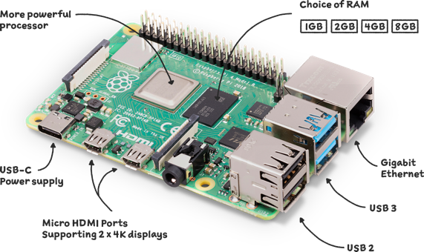

**NODE MCU ESP8266**

The NodeMCU ESP8266 is a low-cost and easy-to-use development board that is based on the ESP8266 Wi-Fi module. It is a popular choice among makers, hobbyists, and developers for IoT projects due to its low cost, small size, and compatibility with various programming languages.

One of the key features of NodeMCU ESP8266 is its ability to connect to Wi-Fi networks, which allows it to communicate with other devices over the internet. This feature makes it an ideal platform for controlling appliances in a circuit remotely.

To control appliances, NodeMCU ESP8266 can be programmed using various programming languages such as C++, Lua, or MicroPython. A developer can write code that reads sensor data, processes it, and sends signals to control devices such as lights, motors, or switches. For instance, one can write a program to turn on a light when a motion sensor detects movement, or to open or close a garage door based on a voice command.

In addition to Wi-Fi, NodeMCU ESP8266 can also be used to connect to other devices using Bluetooth. This feature allows it to communicate with smartphones, tablets, or laptops that support Bluetooth connectivity. A user can control appliances in a circuit by sending commands from a Bluetooth-enabled device.

Furthermore, NodeMCU ESP8266 can also be used to play audio through a speaker. A developer can write code that plays audio files from a micro-SD card or a streaming service, such as Spotify or Apple Music. This feature can be used to create a home automation system that plays music when someone enters the room, or to give voice instructions to control devices.

**RELAY MODULE WITH OPTOCOUPLER**

A relay module with optocoupler is an electronic device that is used to control the flow of electricity in a circuit by using an optocoupler to isolate the control signal from the load circuit. It consists of a relay, which is an electromagnetic switch that can be turned on or off using an electrical signal, and an optocoupler, which is an electronic component that can transfer electrical signals between two isolated circuits.

The relay module typically has several input pins that are used to provide the control signal to the relay. When the control signal is applied, the relay switches the circuit on or off depending on the configuration of the circuit. The optocoupler provides electrical isolation between the control signal and the load circuit, which helps protect sensitive control circuits from high voltage or current levels that may be present in the load circuit.

The relay module can be used to control all types of appliances and devices that are connected to the circuit, such as lights, motors, heaters, and other electrical loads. It is widely used in automation and control systems, as it provides a safe and efficient way to control the flow of electricity in a circuit.

One of the main advantages of using a relay module with optocoupler is its versatility. It can be used in a wide range of applications, from simple home automation systems to complex industrial control systems. It is also relatively easy to install and configure, as it typically comes with clear instructions and diagrams.

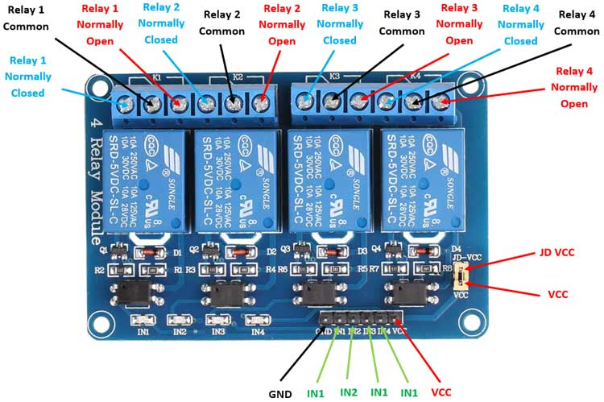

**LITERATURE**

Previously built Voice Controlled Home Automation System have been helpful for disabled people (REF-1), in these systems we have voice controlled system . We through our project improve upon it to create a home automation system that has a central control unit that controls all the appliances with voice automation, also our central automation unit with the help of sensors and camera turns off the system when all the people leave the room and this addresses the big problem of abled as well as disabled people leaving appliances in working state while they are not in the room.

**Previous Home Automation System Review:**

This project can make life easier for bedridden patients and older people as their voice command can trigger the control section that adjusts their bed’s position. It can even control home appliances like lights, fan, AC, and TV, based on the command. Even children can operate the lights at night using voice commands without their parents’ assistance.

There can be an option for text commands instead of voice commands. The proposed system is user-friendly, and no technical assistance is needed for its operation. The author’s prototype is shown in Fig. 1.

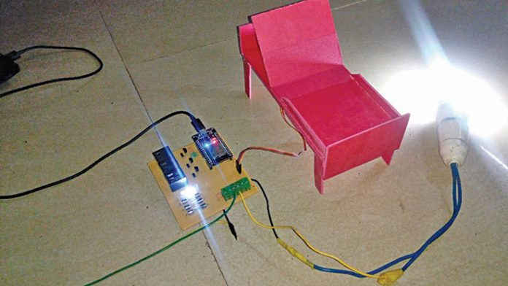

A wireless headset worn by a person transmits the person’s voice to a smartphone that uses Google Assistant app. The app has voice recognition software for interpreting and translating the voice command into digital data that is understandable by the microcontroller to do the required task(s). The control section includes microcontroller with integrated Wi-Fi, relay, and associated circuitry.

## Circuit and working

Block diagram of the system is shown in Fig. 2 and functional block diagram of the developed system is shown in Fig. 3. The system receives voice commands through Google Assistant running on the smartphone. If the command is valid (for instance, Light On), the ‘If This, Then That’ (IFTTT) applet will send the web service request to Blynk server and convert it into digital data, understandable by the microcontroller, and transfer the data to microcontroller wirelessly through Wi-Fi and actuate the device as per the voice command.

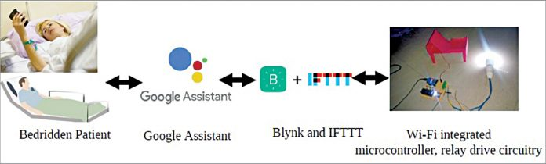

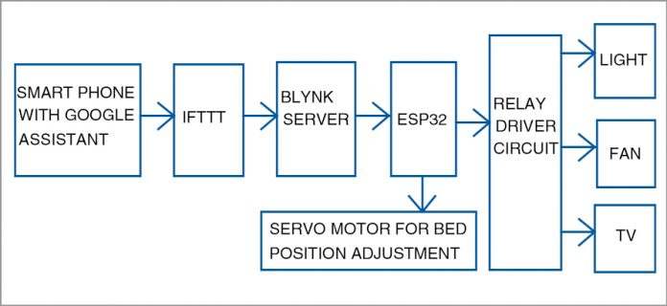

**Camera Module and its working**

Image processing is a form of signal processing in which

the input is an image such as a photograph or video frame, the

output is an image or set of characteristics related to image.

OpenCV is a library of programming functions mainly used for

image processing. It is freely available on the open source

Berkely Software Distribution license. It was started as a

research project by Intel. OpenCV contains various tools to

solve computer vision problems. It contains low level image

processing functions and high level algorithms for face

detection, feature matching and tracking. Some of the main

image processing techniques are given below:

Image Filtering: A technique to modify or enhance an image using linear or non-linear combinations of neighbouring pixels.

Image Transformation: Generating a "new" image from multiple sources to highlight features of interest. Common methods include Hough Transform, Radon Transform, DCT, DFT, and Wavelet Transform.

Object Tracking: Locating objects over a sequence of images, essential in applications like surveillance and medical imaging.

Feature Detection: Identifying specific features of a visual stimulus (e.g., lines, edges, angles) for use in subsequent computer vision algorithms.

OpenCV Modules: Core (basic data structures and functions), ImgProc (image processing), Video (motion estimation and object tracking), ML (machine-learning interfaces), and HighGUI (I/O interfaces and windowing capabilities).

OBJECT DETECTION USING OPENCV

The steps involved in the process are:

1. Reading frames from the video stream: The code uses OpenCV's VideoCapture() function to read frames from a video stream (in this case, from a webcam). The frames are then passed through a series of image processing steps to detect people.
2. Preprocessing the frames: The frames are preprocessed to make it easier to detect people. First, a Gaussian blur is applied to the frame to remove noise. Then, the frame is converted to grayscale to simplify the image.
3. Defining the detection area: The detection area is defined using four points that form a quadrilateral. This area is where people will be detected. Two horizontal lines are also defined within this area to count the number of people going up and down.
4. Background subtraction: The next step is to subtract the background from the preprocessed frame to obtain a foreground mask. This is done using OpenCV's BackgroundSubtractorMOG2() function, which applies a background subtraction algorithm to the frame.
5. Thresholding: The foreground mask is thresholded to create a binary image, where white pixels represent the presence of objects in the scene, and black pixels represent the background.
6. Finding contours: The code uses OpenCV's findContours() function to find contours (i.e., the boundaries of the white objects) in the binary image. The RETR_EXTERNAL flag is used to retrieve only the extreme outer contours, and the CHAIN_APPROX_SIMPLE flag is used to compress horizontal, vertical, and diagonal segments and leave only their endpoints.
7. Filtering contours: Contours that are smaller than a specified area threshold are ignored, as they are likely not people.
8. Tracking people: The remaining contours are tracked to determine if they are new or existing people. A Person class is used to keep track of each detected person's ID, location, age, and direction of movement. If a new contour is found near an existing person, the person's location is updated. If a person is detected crossing the horizontal lines, the appropriate count is incremented, and a message is printed to the console.
9. Drawing: The code draws a circle around each detected person's location and a rectangle around their bounding box. The person's ID is also displayed next to their circle.
10. Displaying the results: Finally, the processed frames are displayed in separate windows for visualisation. The number of people crossing each line is also displayed in the windows.

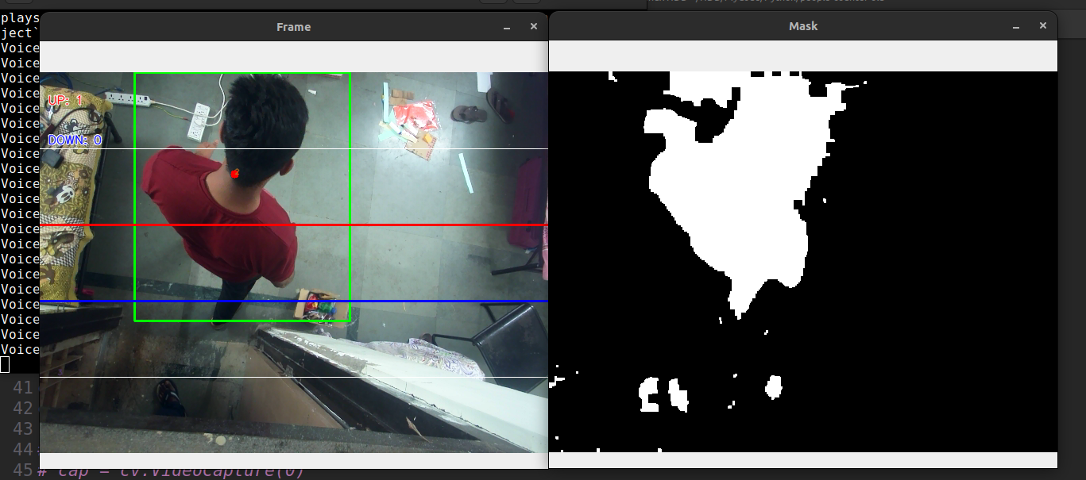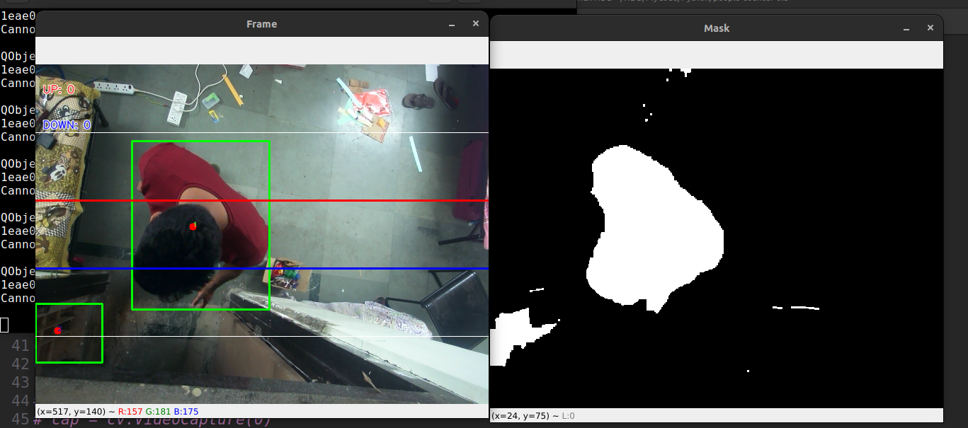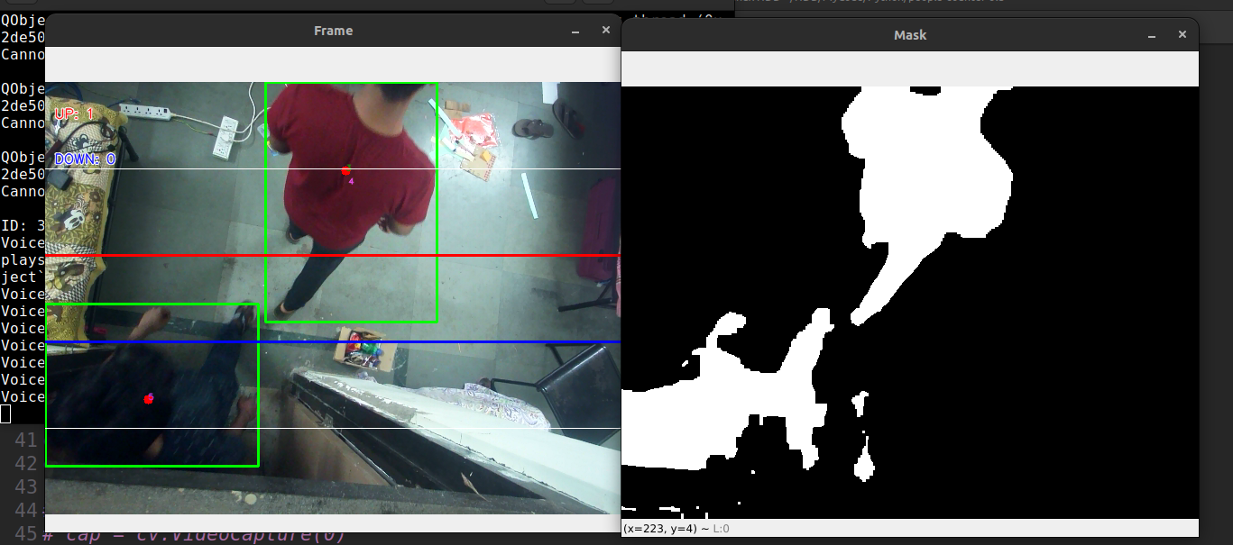

**Voice Control Functions**

* Used C code to create web interface where we can control all

the room appliances remotely.

* Created a local network using wi-fi to connect “Raspberry Pi”

and “NodeMCU”.

* In web interface we have created some APIs which is used in

our voice model.

* We have both voice and manual command interface for comfort

of users who face difficulty in speaking.

* In our voice model to recognize the command given by user we

have used python speech recognition module.

* Based on user command the python “requests module” will call

respective APIs.

* Example: Light On /Light Off and Fan On/Fan Off comes under

user command.

* Also used pyttsx3 module to generate audio such that user

receive the confirmation of command is processing &amp; being

completed.

**Node MCU working in the system**

Raspberry Pi is connected to the Local Area Network (LAN) , this raspberry-pi that is running the main code for the people count using the camera . Node -MCU is connected to raspberry-pi via raspberry-pi’s hotspot . When it gets connected via hotspot NodeMCU creates a local server. In the local server of the NodeMCU different APIs are created in order to the control all the appliances required .

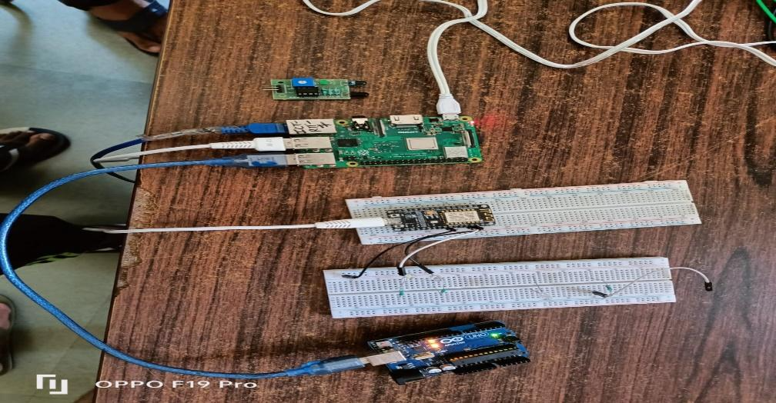

This figure shows NodeMCU is connected to Raspberry-Pi and controlling different appliances.

**Relay and its working**

Relay will be used as a switch to control all AC appliances based on the commands it receives from the NodeMCU.

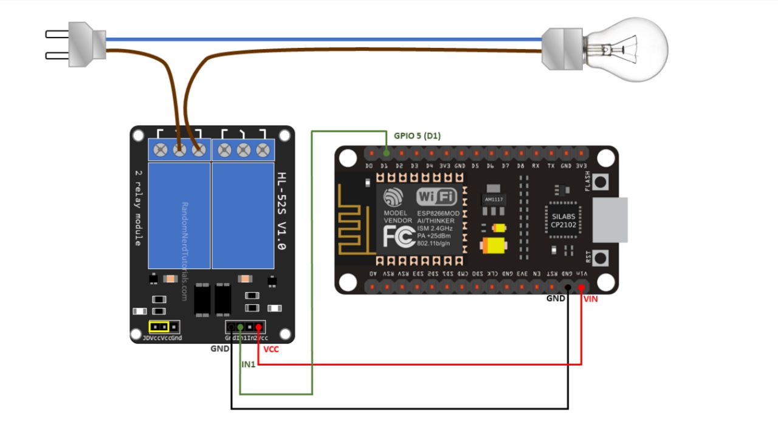

**Ultimate Smart Home Working Website**

* Website is made using ReactJS, backend using NodeJS and Express and for storing IP address MongoDB database is used.
* Recent IP address is fetched from database.
* Website operates on IP address of local server generated by Node MCU to control the appliances.
* Website contains the Add component feature that is used to add the new appliances that we want to control.
* It contains the on/off switch and live feature that tells the user whether we are online or not.

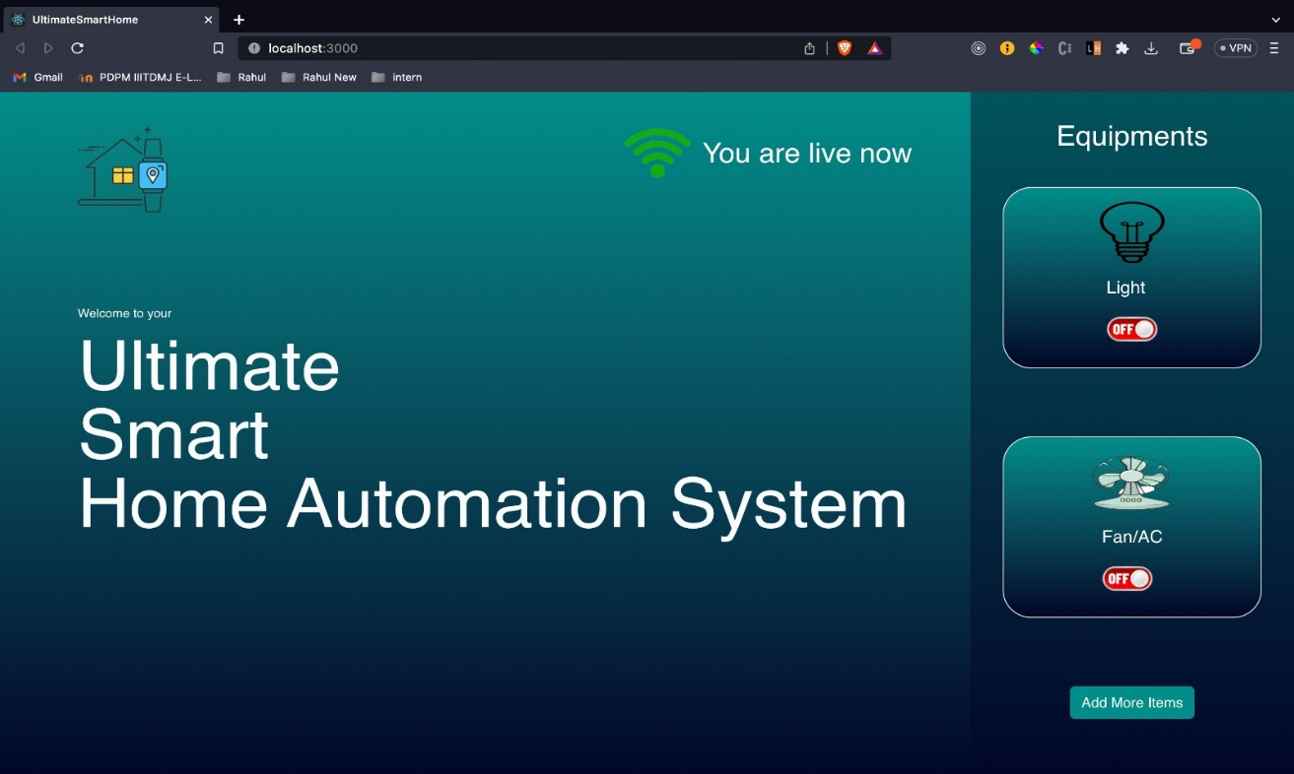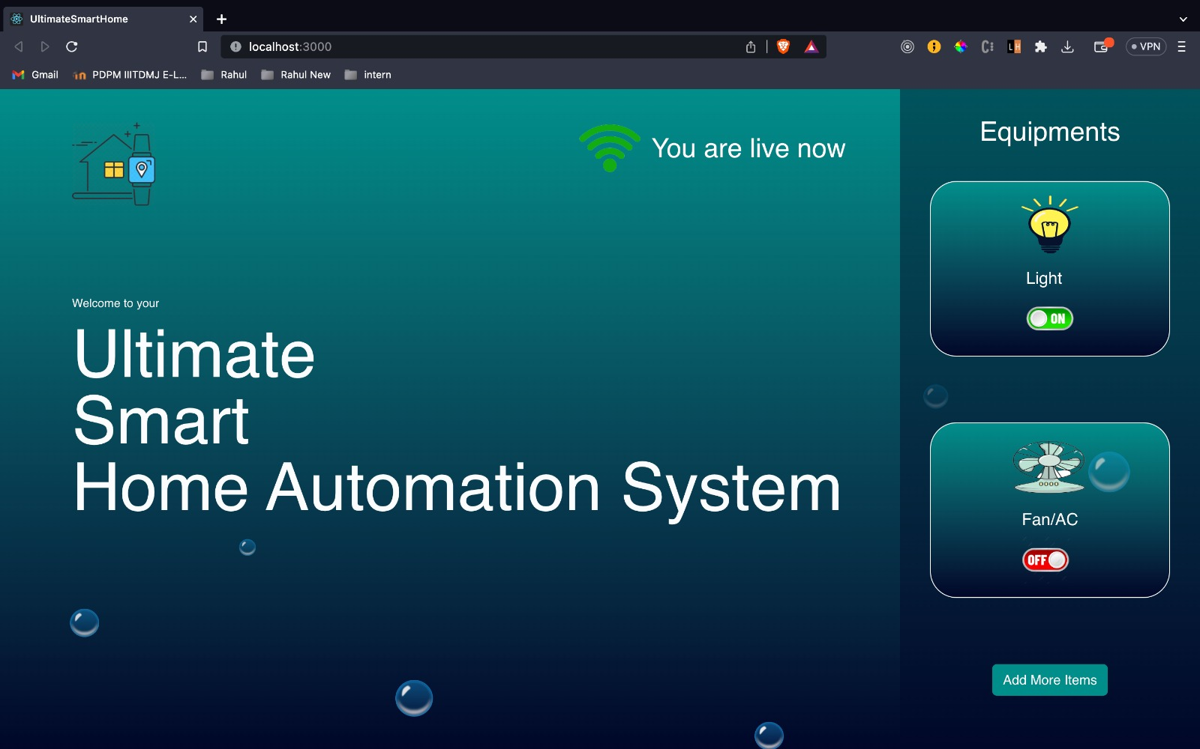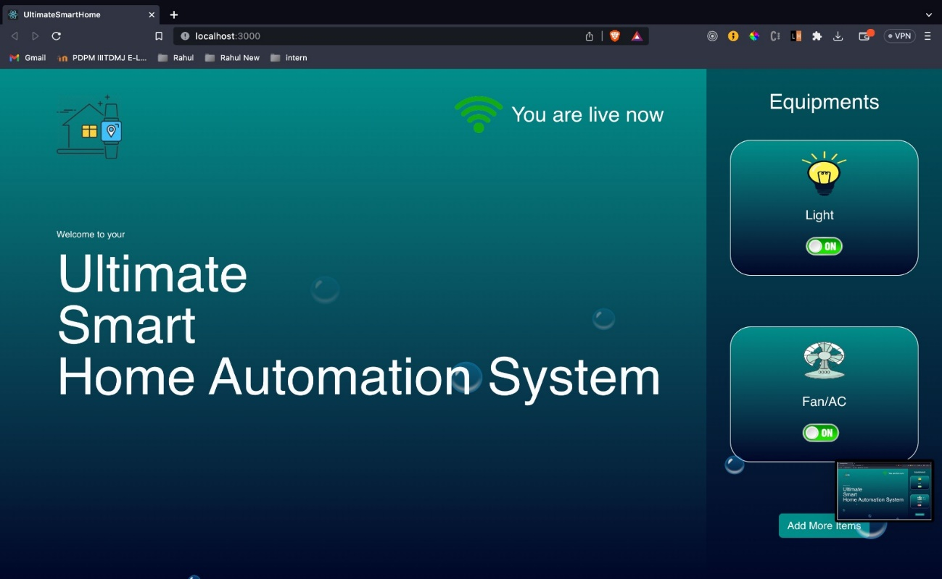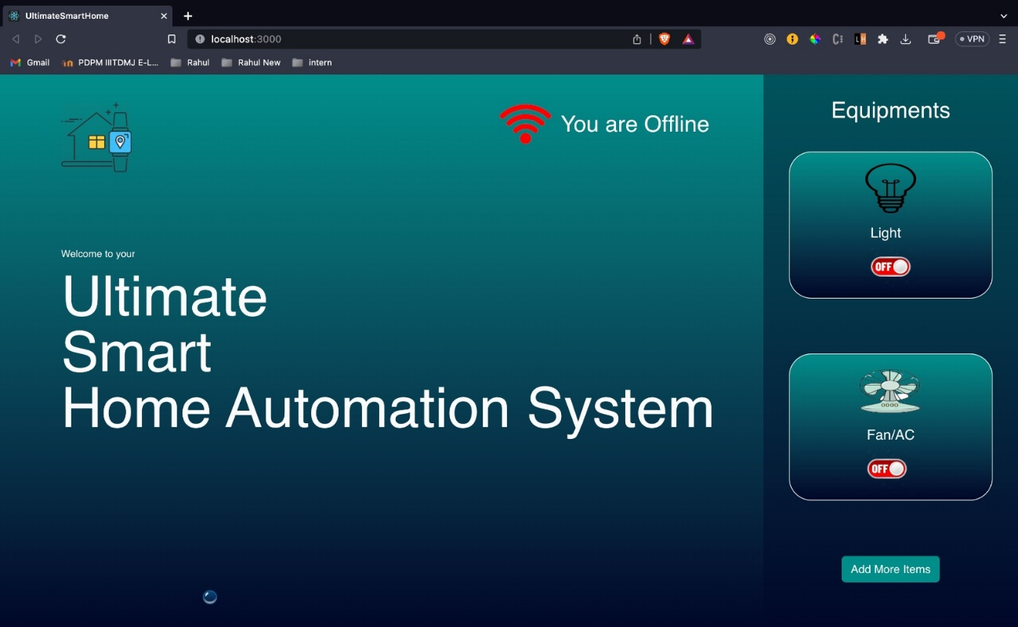

**Ultimate Smart Home Working App**

For convenience and user friendliness we have also created an app , which we can directly use on our phone and control our room automation system to use the appliances. This app is developed with React Native.

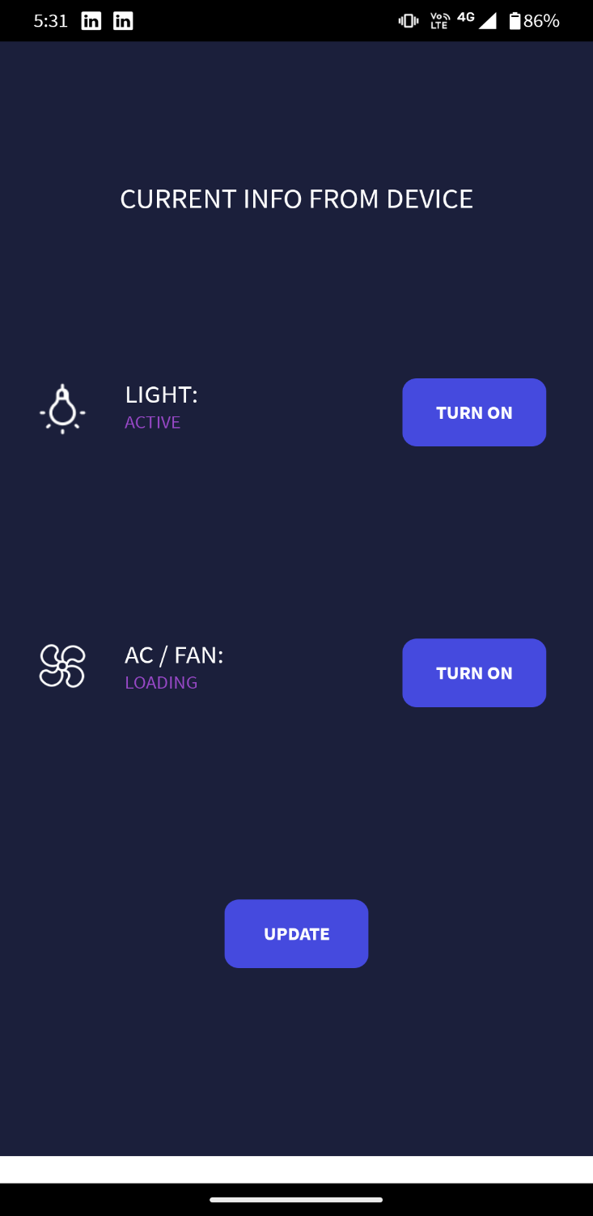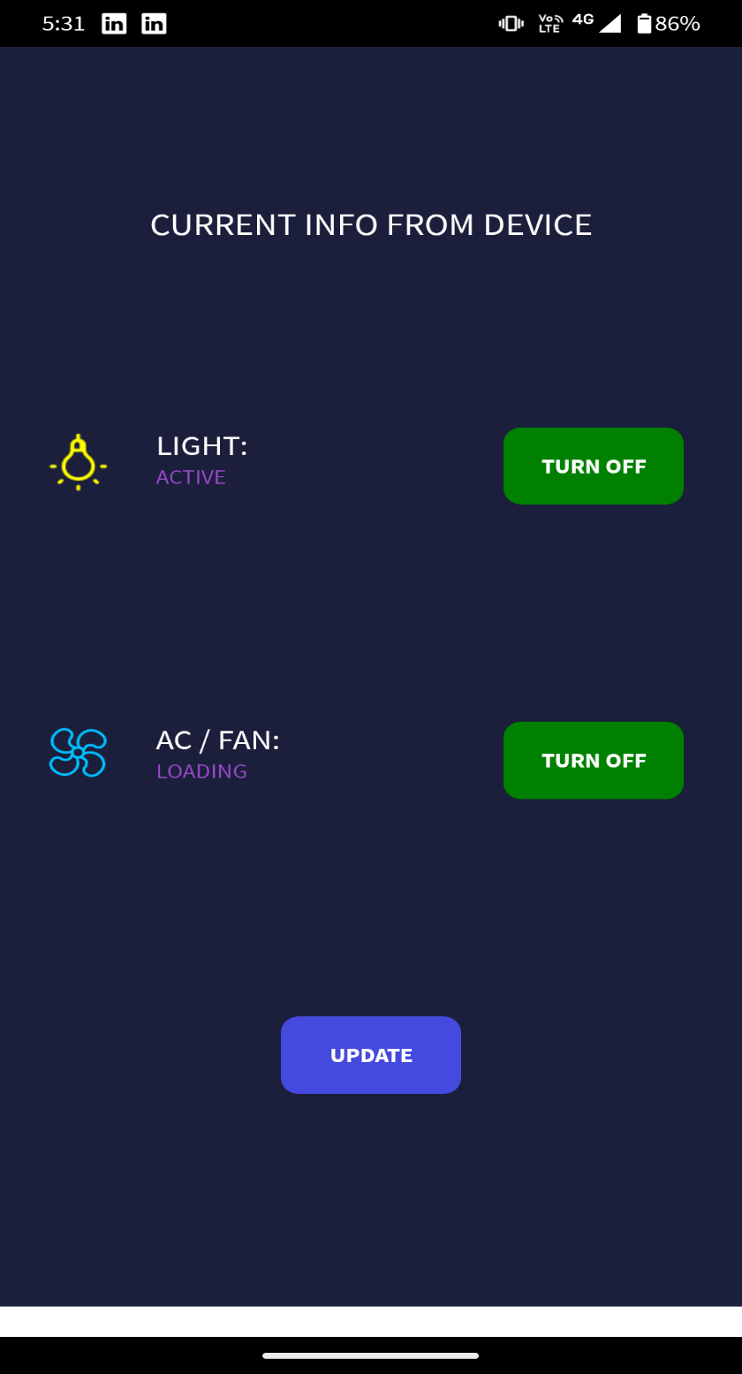

**User Interface of the app including all the features to control appliances**

**Conclusion**

Our room automation system provides a new cutting edge technology with the help of machine learning and electronic relay circuits we aim for the future to build a energy saving system and aim towards a sustainable innovative project to come into use . We have taken special care of the differently-abled people’s need to make them be able to be self dependent . As new innovations and breakthroughs in the field of AI and Machine Learning take place , we plan to improve and include the innovations in our room automation system to make it more and more sustainable for a better future.

**References**

1. <https://www.electronicsforu.com/electronics-projects/voice-activated-home-automation-system>
2. <https://www.researchgate.net/publication/301590571_OpenCV_for_Computer_Vision_Applications>
3. <https://www.researchgate.net/publication/321776293_A_Comprehensive_Analysis_of_Image_Edge_Detection_Techniques>